Architecture Description of

Trade Net Trade & Portfolio Management Software for

Trade Net Brokerage and Financial Services

CSE 4233/6233

Fall 2014

Submitted by:

Kazi Zakia Sultana (ks2190)

# Contents

Contents 2

Using the template 4

License 5

Version history 5

Editions 6

Comments or questions 6

1 Introduction 7

1.1 Identifying information 7

1.2 Supplementary information 7

1.3 Other information 7

1.3.1 Overview (optional) 7

1.3.2 Architecture evaluations 7

1.3.3 Rationale for key decisions 8

2 Stakeholders and concerns 9

2.1 Stakeholders 9

2.2 Concerns 9

2.3 Concern–Stakeholder Traceability 10

3 Viewpoints+ 11

3.1 <Viewpoint Name> 11

3.2 Overview 11

3.3 Framed concerns and typical stakeholders 11

3.3.1 Concerns 11

3.3.2 Typical stakeholders 12

3.3.3 “Anti-concerns” (optional) 13

3.4 Model kinds+ 13

3.5.2 <Model-Kind-Name> operations (optional) 14

3.5.3 <Model-Kind-Name> correspondence rules 14

3.6 Operations on views 14

3.7 Correspondence rules 15

3.8 Examples (optional) 15

3.9 Notes (optional) 15

3.10 Sources 15

4 Views+ 16

4.1 View: <View-Name> 16

4.1.1 Models+ 16

4.1.2 <Model-Name> 16

4.1.3 Known Issues with View 16

5 Consistency and correspondences 18

5.1 Known inconsistencies 18

5.2 Correspondences in the AD 18

5.3 Correspondence rules 18

A Architecture decisions and rationale 19

A.1 Decisions 19

Bibliography 20

# 1 Introduction

## 1.1 Date of Issue and Status

The document is generated for the final submission of the Architecture Description of the Trade Net Trade & Portfolio Management Software. The report is issued on the 10th December, 2014 following the Architecture description template for use with ISO/IEC/IEEE 42010:2011.

## 1.2 Issuing Organization

The document is the final project report for the course Software Architecture and Design (CSE 4233/6233) instructed and supervised by Byron Williams in the department of Computer Science and Engineering of Mississippi State University.

## 1.3 Change History

## 1.4 Summary

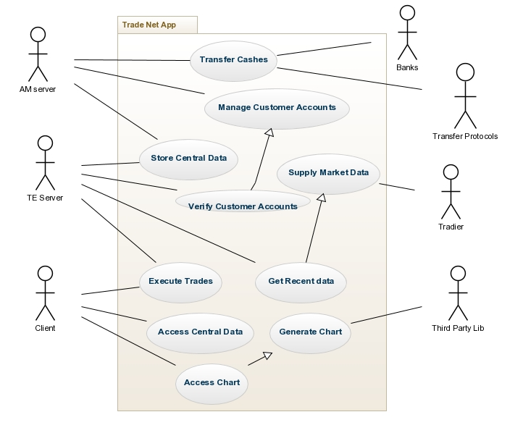

Figure 1: System Level Context Diagram

## 1.3 Context

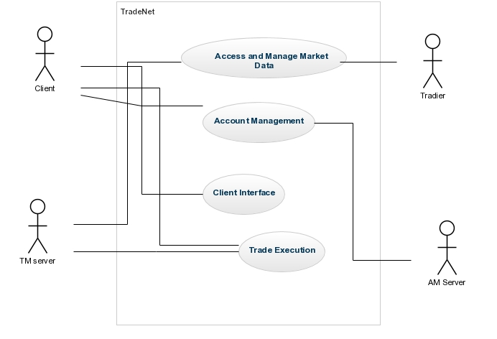

Figure 2: Context Diagram

## 1.3 Glossary

## 1.3 References

[1] http://creativecommons.org/licenses/by/3.0/

## 1.3 Acknowledgement

# 2 Identification of Stakeholders and Concerns

## 2.1 Stakeholders

2.1.1 Project Manager

Project Manager cares about Schedule, resources, contingency plans, overall purpose and constraints, interaction with other systems, hardware environment. He will take care of the top level design and work assignment by visualizing the description.

* + 1. Development Team

They will develop the system using the code resources and infrastructure provided to them for fulfilling the system requirements, As they need to know the requirements of the users and also schedule and budget of the system confined for the development along with their responsibilities, they need to care about architecture description.

* + 1. Maintainers

Maintainers manage the system by getting information from this description. They will get ideas about any changes or impact on the system for managing them properly. They get information about the dependency across the modules and components.

* + 1. Designer

Designers are concerned about the architectural structure and design of the whole system. They mostly care about the top level view and conceptual data model from the architecture description.

* + 1. Customers

Customers will use the system for executing trade, viewing charts, and account management. As they are paying the application for their trade execution, they will care about the overall design of the application and concentrate if it can meet their requirements and interface with other systems properly.

* + 1. Analysts

Analysts will examine if the system meets all the quality attributes properly. Analysts will need information to analyze the system in terms of performance, reliability, security, availability, modifiability.

## 2.2 Concerns

2.2.1 (Concern 1) What are the purpose(s) of the Trade Net?

Trade Net provides brokerage services (i.e., the ability to buy and sale shares of a company) to its customers. Trade Net customers pay for executing their trades and also for gathering updated information provided by the application. So the main purpose of the system is to enable proper and correct execution of trade with the supply of latest market data.

2.2.2 (Concern 2) What are the performance issues of the system?

As the trade execution depends on the current market price, the system should provide the requirement properly. The execution should be time and cost efficient as expected by the customers.

* + 1. (Concern 3) What are the Security issues of the system?

The system maintain cash transfer using wireless protocols and banking interfaces. All kinds of communications and data transfers should be encrypted and secured such that attackers cannot break the system. Moreover, customer account information as managed by AM server should be kept private by maintaining proper access control.

* + 1. (Concern 4) What are the other quality attributes of the system?

The software should also maintain Flexibility for added features and additional types of client interactions for future addition. Availability is also important for avoiding denial of service attacks from any malicious users.

# 3 Viewpoints+

An AD contains multiple architecture views; each view adheres to the conventions of an *architecture viewpoint*. This chapter describes the requirements on documenting viewpoints for an AD.

* Include a specification for each architecture viewpoint used in this AD.

* Viewpoints must be chosen for the AD such that each identified concern from §2.2 is framed by at least one viewpoint.

* Provide a rationale for each viewpoint used.

Rationale could include discussion in terms of its stakeholders, the concerns framed by the viewpoint, relevance of its model kinds and modeling conventions.

* Each architecture viewpoint used in the AD must be specified in accordance with the provisions of ISO/IEC/IEEE 42010, 7.

A detailed template for specifying viewpoints in accordance with the Standard is included in §3.1 below.

NOTE: The latest version of the viewpoint template can be found at   
http://www.iso-architecture.org/42010/templates/.

Repeat and fill-in viewpoint template as needed for each viewpoint used in the AD.

An AD contains one or more architecture views and an architecture viewpoint definition for each view. There is no required ordering of the views or viewpoints within an AD. Readers of the AD will need to refer to the viewpoint specifications to understand the subject of a view, its notations, models and the modeling conventions used. Given a set of views (Vi) and their viewpoints (VPi), the architect might consider the following possible arrangements:

* Viewpoints, first: VPi, followed by the views: Vi
* Interleaved views with their viewpoints: Vi, VPi, Vj, VPj, ...
* Views up front: Vi with the viewpoints deferred to appendices: VPi

## 3.1 <Viewpoint Name>

* Provide the name for the viewpoint.

If there are any synonyms or other common names by which this viewpoint is known or used, record them here.

## 3.2 Overview

Provide an abstract or brief overview of the viewpoint. Describe the viewpoint’s key features.

## 3.3 Concerns and stakeholders

Architects looking for an architecture viewpoint suitable for their purposes often use the identified concerns and typical stakeholders to guide them in their search. Therefore it is important (and required by the Standard) to document the concerns and stakeholders for which a viewpoint is intended.

### 3.3.1 Concerns

* Provide a listing of architecture-relevant concerns to be framed by this architecture viewpoint per ISO/IEC/IEEE 42010, 7a.

Describe each concern.

Concerns name “areas of interest” in a system.

NOTE: Following ISO/IEC/IEEE 42010, **system** is a shorthand for any number of things including man-made systems, software products and services, and software-intensive systems such as “individual applications, systems in the traditional sense, subsystems, systems of systems, product lines, product families, whole enterprises, and other aggregations of interest”.

Concerns may be very general (e.g., Reliability) or quite specific (e.g., How does the system handle network latency?).

Concerns identified in this section are critical information for an architect because they help her decide when this viewpoint will be useful.

When used in an architecture description, the viewpoint becomes a “contract” between the architect and stakeholders that these concerns will be addressed in the view resulting from this viewpoint.

It can be helpful to express concerns in the form of questions that views resulting from that viewpoint will be able to answer. E.g.,

* How does the system manage faults?
* What services does the system provide?

NOTE: “In the form of a question” is inspired by the television quiz show, *Jeopardy!*

ISO/IEC/IEEE 42010, 5.3 contains a candidate list of concerns that must be considered when producing an architecture description. These can be considered here for their relevance to the viewpoint being specified:

* What are the purpose(s) of the system-of-interest?
* What is the suitability of the architecture for achieving the system-of-interest’s purpose(s)?
* How feasible is it to construct and deploy the system-of-interest?
* What are the potential risks and impacts of the system-of-interest to its stakeholders throughout its life cycle?
* How is the system-of-interest to be maintained and evolved? See also: ISO 42010 4.2.3.

### 3.3.2 Typical stakeholders

* Provide a listing of the typical stakeholders of a system who are in the potential audience for views of this kind, per ISO/IEC/IEEE 42010, 7b.

Typical stakeholders would include those likely to read such views and/or those who need to use the results of this view for another task.

Stakeholders to consider include:

* users of a system;
* operators of a system;
* acquirers of a system;
* owners of a system;
* suppliers of a system;
* developers of a system;
* builders of a system;
* maintainers of a system.

### 3.3.3 “Anti-concerns” (optional)

It may be helpful to architects and stakeholders to document the kinds of issues for which this viewpoint is *not appropriate or not particularly useful*. Identifying the “anti-concerns” of a given notation or approach may be a good antidote for certain overly used models and notations.

## 3.4 Model kinds+

* Identify each model kind used in the viewpoint per ISO/IEC/IEEE 42010, 7c.

In the Standard, each architecture view consists of multiple architecture models. Each model is governed by a model kind which establishes the notations, conventions and rules for models of that type. See: ISO/IEC/IEEE 42010, 4.2.5, 5.5 and 5.6.

Repeat the next section for each model kind listed here the viewpoint being specified.

3.5 <Model Kind Name>

* Identify the model kind.

3.5.1 <Model Kind Name> conventions

* Describe the conventions for models of this kind.

Conventions include languages, notations, modeling techniques, analytical methods and other operations. These are key modelling resources that the model kind makes available to architects and determine the vocabularies for constructing models of the kind and therefore, how those models are interpreted and used.

It can be useful to separate these conventions into a *language part*: in terms of a metamodel or specification of notation to be used and a *process part*: to describe modeling techniques used to create the models and methods which can be used on the models that result. These include operations on models of the model kind.

The remainder of this section focuses on the language part. The next section focuses on the process part.

The Standard does not prescribe how modeling conventions are to be documented. The conventions could be defined:

I) by reference to an existing notation or language (such as SADT, UML or an architecture description language such as ArchiMate or SysML) or to an existing technique (such as M/M/4 queues);

II) by presenting a metamodel defining its core constructs;

III) via a template for users to fill in;

IV) by some combination of these methods or in some other manner.

Further guidance on methods I) through III) is provided below.

Sometimes conventions are applicable across more than one model kind – it is not necessary to provide a separate set of conventions, a metamodel, notations, or operations for each, when a single specification is adequate.

#### I) Model kind languages or notations (optional)

Identify or define the notation used in models of the kind.

Identify an existing notation or model language or define one that can be used for models of this model kind. Describe its syntax, semantics, tool support, as needed.

#### II) Model kind metamodel (optional)

A metamodel presents the AD elements that constitute the vocabulary of a model kind, and their rules of combination. There are different ways of representing metamodels (such as UML class diagrams, OWL, eCore). The metamodel should present:

* entities: What are the major sorts of conceptual elements that are present in models of this kind?
* attributes: What properties do entities possess in models of this kind?
* relationships: What relations are defined among entities in models of this kind?
* constraints: What constraints are there on entities, attributes and/or relationships and their combinations in models of this kind?

NOTE: Metamodel constraints should not be confused with architecture constraints that apply to the subject being modeled, not the notations used.

In the terms of the Standard, entities, attributes, relationships are AD elements per ISO/ISO/IEC 42010, 3.4, 4.2.5 and 5.7.

In the Views-and-Beyond approach [1], each viewtype (which is similar to a viewpoint) is specified by a set of elements, properties, and relations (which correspond to entities, attributes and relationships here, respectively).

When a viewpoint specifies multiple model kinds it can be useful to specify a single viewpoint metamodel unifying the definition of the model kinds and the expression of correspondence rules. When defining an architecture framework, it may be helpful to use a single metamodel to express multiple, related viewpoints and model kinds.

#### III) Model kind templates (optional)

Provide a template or form specifying the format and/or content of models of this model kind.

### 3.5.2 <Model Kind Name> operations (optional)

Specify operations defined on models of this kind.

See §3.6 for further guidance.

### 3.5.3 <Model Kind Name> correspondence rules

* Document any correspondence rules associated with the model kind. See §3.7 for further guidance.

## 3.6 Operations on views

Operations define the methods to be applied to views and their models. Types of operations include:

* **construction methods** are the means by which views are constructed under this viewpoint. These operations could be in the form of process guidance (how to start, what to do next); or work product guidance (templates for views of this type). Construction techniques may also be heuristic: identifying styles, patterns, or other idioms to apply in the synthesis of the view.
* **interpretation methods** which guide readers to understanding and interpreting architecture views and their models.
* **analysis methods** are used to check, reason about, transform, predict, and evaluate architectural results from this view, including operations which refer to model correspondence rules.
* **implementation methods** are the means by which to design and build systems using this view.

Another approach to categorizing operations is from Finkelstein et al. [2]. The work plan for a viewpoint defines 4 kinds of actions (on the view representations): *assembly actions* which contains the actions available to the developer to build a specification; *check actions* which contains the actions available to the developer to check the consistency of the specification; *viewpoint actions* which create new viewpoints as development proceeds; *guide actions* which provide the developer with guidance on what to do and when.

## 3.7 Correspondence rules

* Document any correspondence rules defined by this viewpoint or its model kinds.

Usually, these rules will be across models or across views since, constraints within a model kind will have been specified as part of the conventions of that model kind. See: ISO/IEC/IEEE 42010 4.2.6 and 5.7.

## 3.8 Examples (optional)

Provide helpful examples of use of the viewpoint for the reader (architects and other stakeholders).

## 3.9 Notes (optional)

Provide any additional information that users of the viewpoint may need or find helpful.

## 3.10 Sources

* Identify sources for this architecture viewpoint, if any, including author, history, bibliographic references, prior art, per ISO/IEC/IEEE 42010, 7e.

# 4 Views+

Much of the material in an AD is presented through its architecture views. Each view follows the conventions of its governing viewpoint. A view is made up of architecture models.

* Include an architecture view for each viewpoint selected in §3.

Repeat and complete the following section for each architecture view in the AD.

## 4.1 View: <View Name>

* Give the architecture view a <View Name>.

* Provide any identifying and supplementary information about <View Name>.

The details of this information will be as specified by the organization and/or project. See §1 for examples of identifying and supplementary information.

Views have their own identifying and supplementary information distinct from ADs because they may be developed and evolve separately over the lifetime of a project.

* Identify the viewpoint governing this view from among those identified in §3.

See also: ISO/IEC/IEEE 42010, 5.5

### 4.1.1 Models+

An architecture view is composed of one or more architecture models.

* Provide one or more architecture models adhering to the governing viewpoint.

* The models must address all of the concerns framed by the view’s governing viewpoint and cover the whole system from that viewpoint.

Repeat the section below for each model.

### 4.1.2 <Model Name>

* Each architecture model shall include version identification as specified by the organization and/or project.

* Each architecture model shall identify its governing model kind and adhere to the conventions of that model kind from §3.5.

See ISO/IEC/IEEE 42010, 5.4.

An architecture model may be a part of more than one architecture view. This enables sharing of details and addressing distinct but related concerns without redundancy. Other uses of multiple models: aspect-oriented style of architecture description: architecture models shared across architecture views can be used to express architectural perspectives [6] and architecture textures [5]. Architecture models can be used as containers for applying architecture patterns or architecture styles to express fundamental schemes (such as layers, three-tier, peer-to-peer, model-view-controller) within architecture views.

### 4.1.3 Known Issues with View

* Document any discrepancies between the view and its viewpoint conventions.

Each architecture view must adhere to the conventions of its governing architecture viewpoint.

Known issues could include: inconsistencies, items to be completed, open or unresolved issues, exceptions and deviations from the conventions established by the viewpoint. Open issues can lead to decisions to be made. Exceptions and deviations can be documented as decision outcomes and rationale.

# 5 Consistency and correspondences

This chapter describes consistency requirements, recording of known inconsistencies in an AD, and the use and documentation of correspondences and correspondence rules.

## 5.1 Known inconsistencies

* Record any known inconsistencies in the AD.

Although consistent ADs obviously are to be preferred, it is sometimes infeasible or impractical to resolve all inconsistencies for reasons of time, effort, or insufficient information.

∆ An architecture description should include an analysis of consistency of its architecture models and its views.

## 5.2 Correspondences in the AD

* Identify each correspondence in the AD and its participating AD elements. Identify any correspondence rules governing

Correspondences are used to express, record, enforce and analyze consistency between models, views and other AD elements within an architecture description, between ADs, or between an AD and other forms of documentation.

AD elements include instances of stakeholders, concerns, viewpoints and views, model kinds and models, decisions and rationales. Constructs introduced by viewpoints and model kinds are also AD elements.

Correspondences are n-ary mathematical relations. Correspondences can be depicted via tables, via links, or via other forms of association (such as in UML).

## 5.3 Correspondence rules

* Identify each correspondence rule applying to the AD.

Correspondence rules can be introduced by the AD, by one of its viewpoints, or from an architecture framework or architecture description language being used.

* For each identified correspondence rule, record whether the rule holds (is satisfied) or otherwise record all known violations.

# A Architecture decisions and rationale

It is not required by the Standard to capture architecture decisions. This section describes recommendations (“shoulds”) for their recording.

## A.1 Decisions

∆ Provide evidence of consideration of alternatives and the rationale for the choices made.

∆ Record architecture decisions considered to be key to the architecture of <System of Interest>.

Areas to consider to selecting key decisions include those:

* affecting key stakeholders or many stakeholders
* essential to project planning and management
* expensive to enforce or implement
* highly sensitive to changes or costly to change
* involving intricate or non-obvious reasoning
* pertaining to architecturally significant requirements
* requiring major expenditures of time or effort to make
* resulting in capital expenditures or indirect costs

∆ When recording decisions, the following information items should be considered:

* unique identifier for the decision
* statement of the decision
* correspondences or linkages concerns to which it pertains
* owner of the decision
* correspondences or linkages to affected AD elements
* rationale linked to the decision
* forces and constraints on the decision
* assumptions influencing the decision
* considered alternatives and their potential consequences

See [7] and references there for various approaches to documenting decisions compatible with the Standard.

The template ends here!

# Bibliography

[1] http://creativecommons.org/licenses/by/3.0/